Kinsley Campground Correction Fish Habitat Restoration

Union Soil & Water Conservation District

# Photograph Monitoring Points

**Established December 18, 2020**

Permanent photographic monitoring points have been established around Catherine Creek RM 44 to monitor visual changes of the Kinsley Campground Correction Fish Habitat Restoration site. A total of 3 locations have been monumented with steel t-posts and 5 photographs were taken (Table 1). A latitude and longitude are documented for each monumented location and a compass bearing for each photograph is noted (map datum WGS 84). Pre-project photographs were taken on December 14, 2020 and will be repeated after construction activities are completed and on an annual basis thereafter.

Table 1. Monumented photograph points for the Kinsley Campground Correction Fish Habitat Restoration Project.

|  |  |  |  |  |
| --- | --- | --- | --- | --- |
| **Monument Location** | **Photo Point** | **Latitude** | **Longitude** | **Bearing** |
| 1 | 1 | 45.183702° | -117.822564° | 128 |
| 2 | 2 | 45.183530° | -117.822236° | 215 |
| 3 | 3 | 45.183321° | -117.821796° | 276 |
| 4 | 4 | 45.183491° | -117.822180° | 267 |

The photograph monument locations are shown in Figure 1.

Figure 1. Kinsley Campground Photograph Monitoring Point Locations.

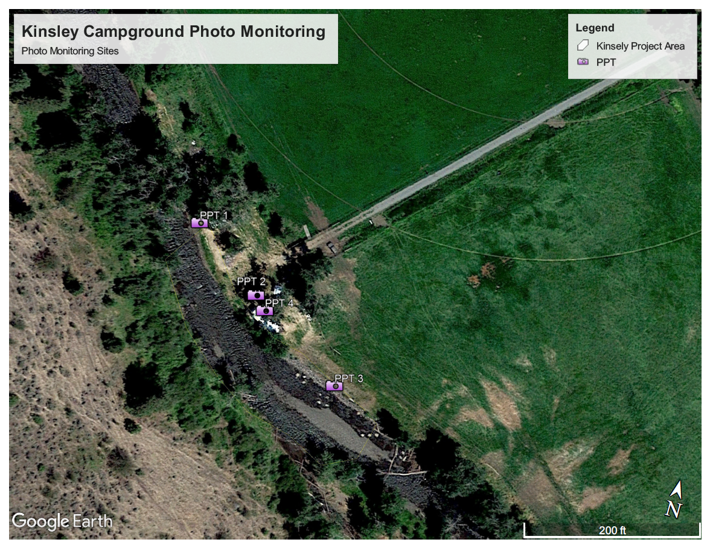

Photographic Monitoring Points

Figure 2. Kinsley Campground Photo point #1 (Pre Project top, Post Project Bottom) at a bearing of 128 degrees, post-project August 17, 2021

Figure 3. Kinsley Campground Photo point #2 (Pre Project top, Post Project Bottom) at a bearing of 215 degrees, post-project August 17, 2021

Figure 4. Kinsley Campground Photo point #3 (Pre Project top, Post Project Bottom) at a bearing of 276 degrees, post-project August 17, 2021

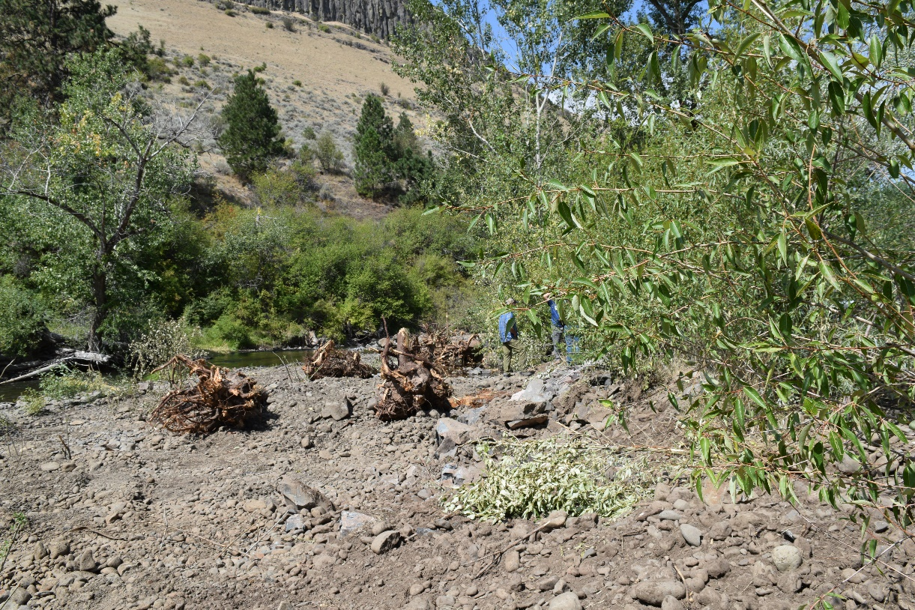

Figure 5. Kinsley Campground Photo point #4 (Additional Photo added post implementation) at a bearing of 294 degrees, post-project August 17, 2021.

