September 3, 2019
1114 J Ave.
La Grande, Oregon 97850

(541) 663-0570
Fax: (541) 962-1585

www.grmw.org

Board of Directors
Chair:
Susan Roberts
Vice-Chair:
Donna Beverage

Allen Childs
Norm Cimon
Jim Webster
Jed Hassinger
Joe McCormack
Jeff Yanke
Larry Nall
Dave Yost

Staff:
Alexandra Towne
Mary Estes
Ian Wilson
Kayla Morinaga
Jesse Steele
Connar Stone

Frank Drake
Oregon Dept. of Fish and Wildlife
107 20th St.
La Grande, OR. 97850

RE: Wallowa River – McDaniel Fish Habitat Restoration Project III

Dear Frank,

At a regularly scheduled meeting of the Grande Ronde Model Watershed Board of Directors on August 27, 2019, your project proposal titled Wallowa River – McDaniel Fish Habitat Restoration Project III was reviewed. GRMW staff recommended the project be funded and the Board approved the project for the following amount:

BPA FY 2019 $334,668

Because several line items appear to be higher than normal, GRMW is requesting that the awarded bid be provided to both GRMW and BPA. This will help us refine current price ranges for the line items in this project budget. Please attach the awarded construction bid sheet to your Pisces contract when it is available. Please work with Tracy Hauser at BPA to confirm funding and finalize contract information in cbfish.org.

Congratulations! We look forward to seeing the implementation of this project.

Sincerely,
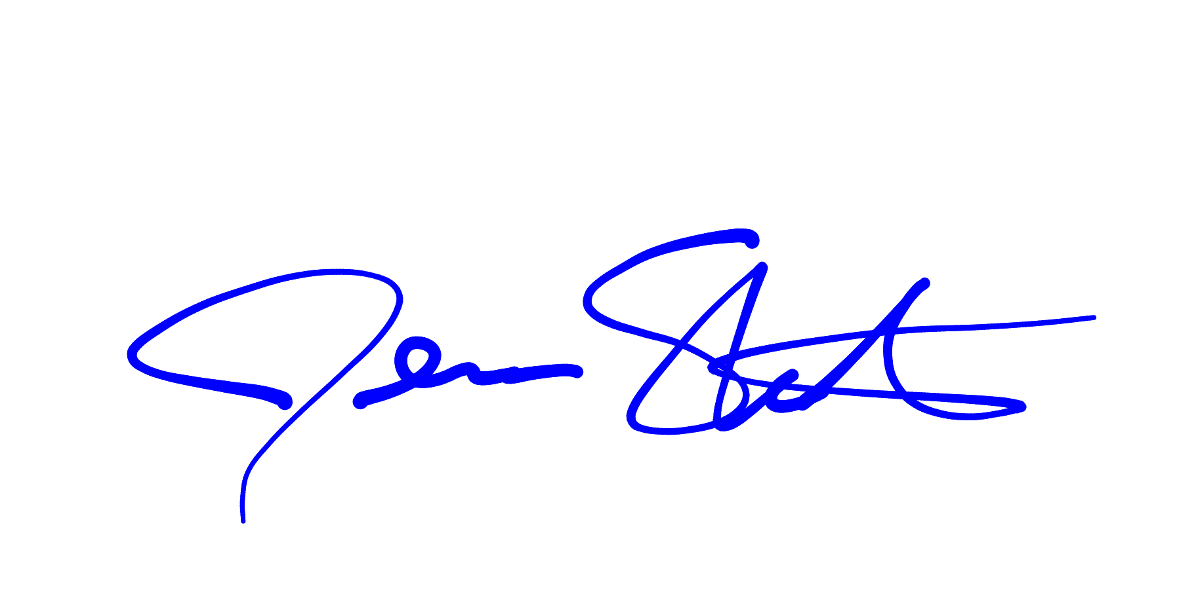
Jesse Steele
Executive Director

CC:
Tracy Hauser, BPA tlhauser@bpa.gov
Sean Welch, BPA spwelch@bpa.gov
Jeff Yanke, ODFW jeff.yanke@state.or.us
Ian Wilson, GRMW ian@grmw.org
Susan Roberts, GRMW Board Chair sroberts@co.wallowa.or.us

